The Report of the Tikanga Toru Youth Commission
to the 62nd General Synod / Te Hinota Whanui
The Tikanga Toru Youth Commision (T3YC) was established by General Synod in 2010. Its purpose is to strengthen and support youth ministry through advocacy, training and fellowship. The T3YC:

- Governs Three-Tikanga Youth Structures
- Advocates for Youth Ministry throughout the
Church
- Acts as the Standing Committee for the Tikanga Youth Synod
- Supports the Three-Tikanga Youth Commissioner
The kaupapa of the T3YC is:
To disciple young people to be Christ centred in our Three-Tikanga (3T) Church
In this season, the T3YC is guided by and seeks to exemplify the following values:
- We exercise unreasonable manaakitanga; not only are you welcome, but we’re committed to bridging any obstacle that stands in the way of us being together in Christ.
- We work at high trust relationships; we are committed to speaking the truth in love, high trust relationships, being open, honest, and vulnerable.
- We listen to each other’s talanoa; together we have a thousand stories, of who we've been, who we are and who we will be—of God and God's action. Every story, no matter the inconvenience of hearing or telling it, is important.
- We operate with creativity and imagination; we have deep roots but we are not shackled to old ways of doing things. We are committed to asking, time and again, “What new work is God doing?”
- We aspire to be edge-walkers; as God goes before us all, we are committed to embracing our calling to go to the margins and beyond.
The Canon overseeing the establishment of the T3YC came out of twenty years of developing and resourcing youth ministry in a 3T context and a review called for by the General Synod Standing Committee of all 3T youth ministry and past bodies responsible for this ministry. The T3YC took over the work of several bodies within 3T Youth Structures and has grown as a body while working hard at being more responsive to the struggle and potential of young people in our 3T Church.

Introduction
He hōnore, he korōria ki te Atua i runga rawa, he maungārongo ki runga i te mata o te whenua, he whakaaro pai ki ngā tāngata katoa.
Tēnā tātau i ō tātau tini mate e whakangaro haere tonu atu nei ki te pō, ki ngā marae huihuinga o te iwi kua moe. Ko tātau nei ō rātau morehu ki te ao tūroa nei, heoi e ngā mate, haere, haere, haere. Moe mārie mai i roto i te atawhai o Te Ariki. Tātau ngā waihotanga mai o rātau mā, tēna tātau katoa.
The Tikanga Toru Youth Commission, joined by the Archbishops and hosted by The Most Rev Brown Turei in Te Tūranganui-ā-Kiwa, gathered at the close of 2015 to wānanga around its kaupapa.
Over two days, it reflected on its work, the present landscape of youth ministry and the Church, and re-examined its purpose moving forward.
Through talanoa each Tikanga and the T3YC as a whole identified the areas in which it has grown, the strengths and fruits of its work, and the weaknesses and areas that have borne too little fruit; it discerned the challenges that remain and where it could best dedicate its gifts, resources, time, and energy in this season.
Since its establishment, the T3YC has continued to bring together and develop extensive experience in forming and engaging in genuine, committed, high trust 3T relationships across our 3T youth networks—creating safe and welcoming spaces to expose rangatahi to positive cross-Tikanga experiences and opportunities for sharing, learning and the building up of youth ministry.
The T3YC has done this though events such as the annual Tikanga Youth Synod, bringing together young leaders from across Aotearoa-NZ and Polynesia to discuss important issues affecting young people and the Church and to figure out steps we can take around issues for advocacy and action on the ground; the biennial Tikanga Youth Exchange, gathering young people every two years to build relationships and experience other cultures and youth ministry in Pākehā, Māori and Pasifika contexts to learn about each other while immersing ourselves in the host Tikanga; the Pononga Programme for General Synod/Te Hīnota Whānui (GS/THW) youth stewards, where pononga offer an important service to the smooth running of the conference, helping hosts, staff and other volunteers in everything from technical and office support to hospitality, as well as getting to experience and contribute to the life and mission of our Church alongside its leaders; the Diocesan Youth Wave in Polynesia and Kawea Te Rongopai in Te Tairāwhiti among other youth events at diocesan levels where the T3YC has encouraged and facilitated 2 and 3 Tikanga collaboration and involvement; Raukura, offering professional development and relationship-building to young leaders involved in regional, diocesan, and/or Tikanga youth ministry; putting on ‘Prepare the Way’, the Theological Hui in 2015, where the T3YC took up the challenge to gather participants from across Aotearoa-NZ and Polynesia for three days of fellowship, worship, listening to God, and 'hovering over the face of the deep'—examining what it means to 'prepare the way' and what it means to be people of 'the way'; our 3T approach to teaching Supporting Youth, Childrens, and Young Families Ministry at St John’s College, Auckland, in youth ministry block courses; through to collaborating with ecumenical partners to produce a resource detailing Sustainable Practices for Youth Ministry, and working at resources for Mentoring Young People and Doing Theology.
In looking at its kaupapa and over its work the T3YC recognised that it has benefitted different parts of the 3T youth network at times, along with our network of 3T youth ministry leaders, as pacesetters for youth ministry and our 3T relationships. It has created moments in time where it realises the promise of our 3T Church at events and through its work—where boundaries vanish and we cease to be together as three separate Tikanga and are with and for one another before God—and it has endeavoured to translate these moments longer-term to youth ministry at the grassroots.
It has learned that our 3T relationship requires grace and humility; being 3T is both aspirational and invitational—holding forth the promise and potential of being 3T together and inviting one another to do the hard work of wrestling with our relationship in honest and lifegiving ways.
However, where the overwhelming majority of us, day by day, are one Tikanga on the ground the challenge for the T3YC remains to translate what we do at a 3T level to the flaxroots.
Looking ahead, the T3YC has redoubled its commitment to ‘greening’ everything it does—gearing its resources, work and events towards high school aged students and ensuring the environments we create are fit for them rather than defaulting to making young people only conform to fitting our environments as a Church.
The T3YC has also increased its commitment to strengthening strategic common life partnerships and vision-led collaboration at every level to support 3T relationships on the ground, disciple young people, and develop young leaders.
Indeed, discipling young people (who disciple others) to be Christ-centred was considered to lay at the heart of the purpose for the T3YC and served to form the basis of its kaupapa for this season: “He whakahau i te rangatahi kia pono ki a Te Karaiti i roto i tō tātau Hāhi Tikanga Toru” / “To disciple young people to be Christ-centered in our Three-Tikanga Church.”
Discipleship also forms the cornerstone of three questions the T3YC feels it needs to ask in its mission and ministry and of every event and task it undertakes:
- How is this helping to make disciples?
- How is this developing youth leadership/young leaders?
- How is this helping us to be and do 3T at the flax-roots level?
Building on the good work it has done to date, the T3YC is excited for what lays ahead and how it can work at its mission to disciple young people to be Christ-centred in our 3T Church.
Nā reira, e ngā mana, e ngā reo, e ngā karangaranga maha, e ō mātau rangatira, ngā karere, ngā māngai hoki o te Haahi Mihinare ki Niu Tireni, ki Aotearoa, ki ngā Moutere o te Moananui-ā-Kiwa, tēnā koutou, tēnā koutou, tēnā tātau katoa.

PROGRAMMES & EVENTS 2014-2016
GS/THW Youth Stewards 6-16 May 2014
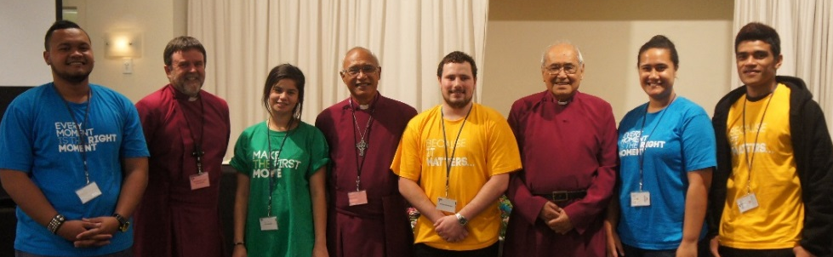
“It will not be so among you; but whoever wishes to be great among you must be your servant, and whoever wishes to be first among you must be your slave” Matthew 20:26-27
The vision of the Pononga Programme is to nurture servant leadership at the highest levels of the Anglican Church in Aotearoa, New Zealand and Polynesia (ACANZP)—presenting young people with an opportunity to engage with the mind and workings of the Church and its constituent parts, building relationships and “brushing shoulders” with the leaders of the same as well as profiting equally with the delegates from everything laid on for the conference. All of this makes GS/THW an especially formative event for the youth stewards. Many have emerged in the past with a redoubled commitment to the Church—going on to represent their dioceses at subsequent meetings of GS/THW and on other decision making bodies, and engaging in the ministry of the Church. In turn, the presence of the stewards has a good effect on the GS/THW with young people woven throughout the experience from worship, through business to peripheral activities.
In 2016, six young people served the GS/THW as stewards from 8-16 May, gathering a couple days earlier for orientation, to serve the Tikanga Caucuses and take part in Tikanga Youth Exchange, which dovetailed with the Synod (extending their commitment to two weeks).
It was a particularly demanding meeting at times considering some of the GS/THW’s work in 2014 but the stewards performed well alongside staff. The Pōwhiri at Waitangi & the Opening Worship Service in which the stewards were able to take full part were popular highlights as well as the opportunity to be among the first visitors to the new open air auditorium, Te Rore Kaahu, overlooking Rangihoua.
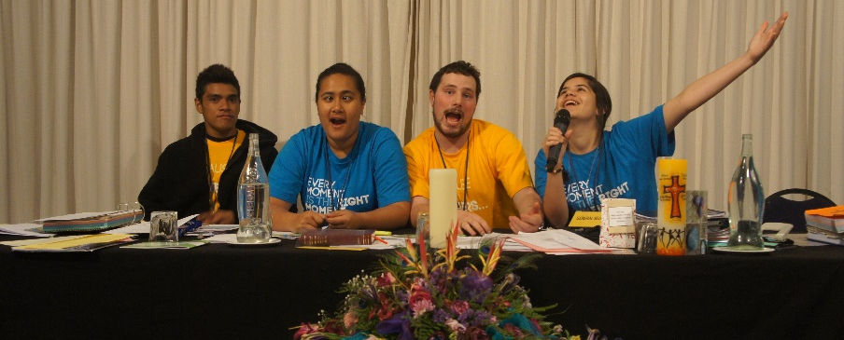
The T3YC also works to ensure that stewards emerge from the experience with a good working knowledge of the workings of Synod, have learned the processes and identified issues relevant to youth ministry within the Anglican Church, and have a greater appreciation of the work of Synod and its importance to the life and mission of our 3T Church. The Youth Stewards were able to see & hear the presentations & have the opportunity to participate in the debate; a very great group of young people who provided exceptional service to our Church.
The stewards in 2016 were: Anastarshia Havili (NZ-Polynesia), Faaea Tiatia (American Samoa), Soatame Tuifua (Waiapu/Tonga), John Graveston (Christchurch/Dunedin), Serena Williams (Taitokerau) and Zoe Van Tilburg-Gerrard (Tairawhiti).

TIKANGA YOUTH EXCHANGE 1-8 MAY 2014
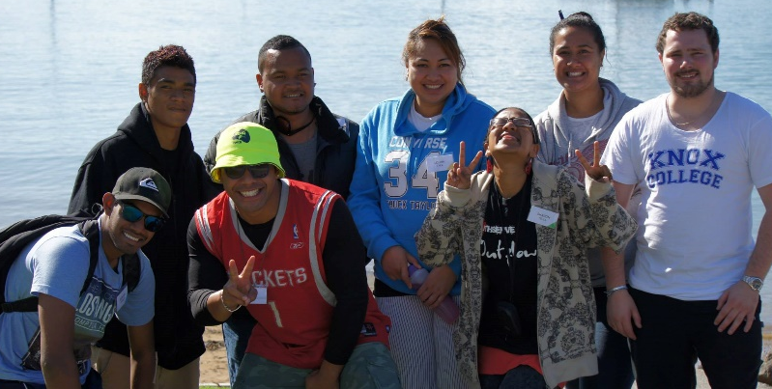
The hospitality and hosting was amazing at Tikanga Youth Exchange (TYE) in 2014, taking place immediately prior to, and overlapping with, GS/THW, and the experience laid on for attendees was certainly memorable. The Rt Rev Te Kitohi Pikaahu personally led young people and leaders attending TYE around some of the founding sites of Christianity and Aotearoa-NZ, including the first Methodist Mission, the first base for Roman Catholicism in the North, Waitangi, and Oihi.

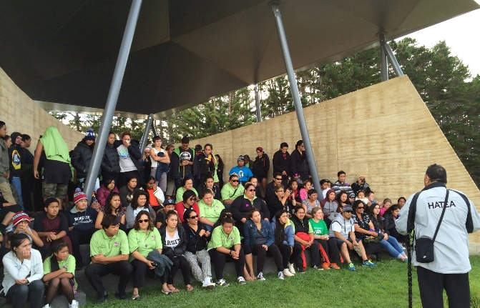
Participants were also honoured in that, having been welcomed and becoming a part of that place in the immediate lead up to GS/THW, they were able to stand with the iwi kāenga in the opening pōwhiri for GS/THW in 2014 as well as helping to lead and be a part of the opening service.
TYE in 2016 will be hosted by Tikanga Polynesia, 28 November – 5 December.

Kawea Te Rongopai 29 Sep – 6 Oct 2014
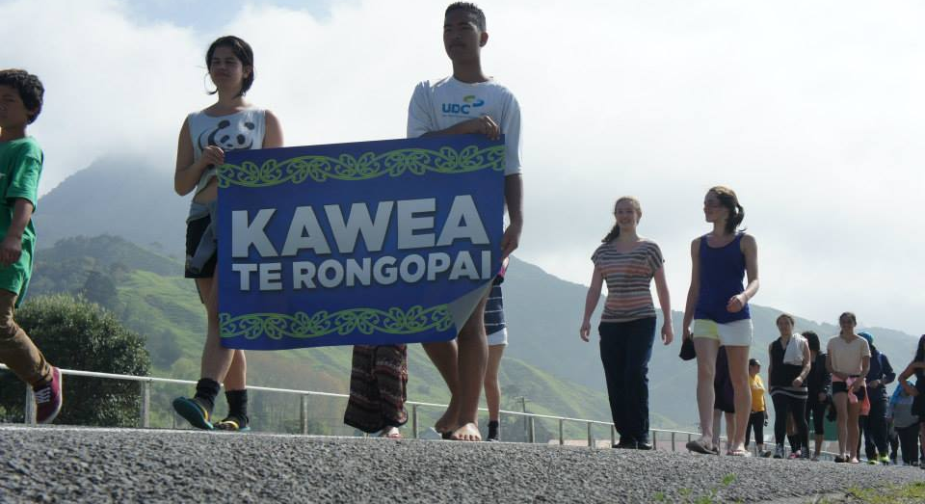
‘Kawea Te Rongopai’, Tairāwhiti’s ‘Gospel Relay’, saw young people from all three Tikanga join together in ‘carrying the Gospel’ over 1000 kilometres beginning at Wharekahika in the north of Te Pīhopatanga o Te Tairāwhiti and ending at the Manawatū River on its southern boundary. Along the way, young people visited and learned the history and whakapapa of every church, marae, community and significant site and landmark they could get to.
Kawea Te Rongopai was the brainchild of two young people, then 12, in the Waiapu Valley, who when asked what they could do to mark the bicentenary of the Gospel’s arrival in Aotearoa, and the 180th anniversary of Piripi Taumataakura’s return of the same to the Waiapu Valley, said, “we can run.”
The T3YC encouraged involvement by all three Tikanga in each leg, with young people and leaders from Tikanga Pākehā and Polynesia joining Te Tairāwhiti at different stages on the over two-year journey.
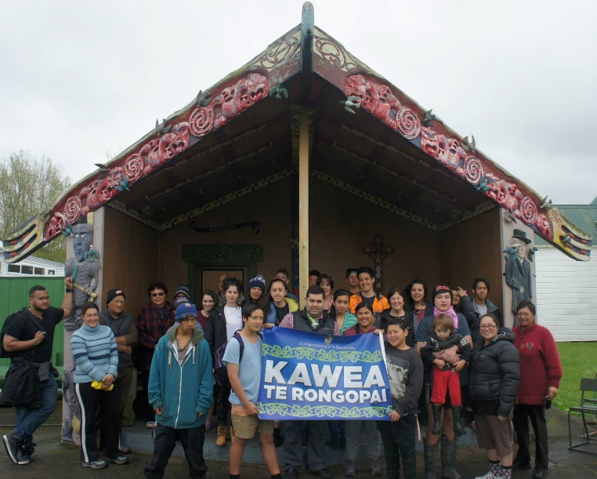
The final leg, taking place over a week in late 2014, went from south of Gisborne to the southern boundary of Te Tairawhiti past Woodville. As in the first two legs, this journey retraced the stories of the carrying of the gospel in its early spread, and how it continues to be shared today, across the region—through Māhia, up in to Waikaremoana, through Wairoa, and down into the Hawke’s Bay—with the young people sharing their journeys of faith in worship and prayer and through story and song with each community along the way.
ASP Supporting Childrens’ and Youth Ministry 17-18 Oct, 2014; 22-24 June, 2015
The Supporting Children, Youth and Young Families Ministry Paper, as part of the Anglican Studies Programme at St John’s Theological College, Auckland, was delivered as a block course in 2014 (20 students) and again in 2015 (11 students). The courses covered contemporary perspectives on Anglican ministry to children, young people, and young families by offering current and traditional definitions of what ‘youth’ and ‘children and young families ministry’ means; outlining Tikanga, Scriptural, ecclesiological and liturgical perspectives on these ministries; critiquing current issues in church and community; and, offering models, definitions, and praxis options as practical solutions.
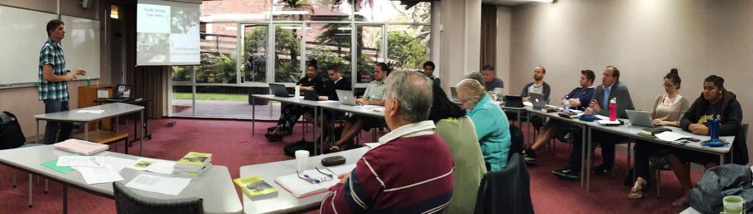
The course was facilitated by the T3YC and the Tikanga Pākehā National Youth Advisor with a number of expert contributions from across the Church as well as case studies on grassroots youth ministry in each Tikanga seeking to equip students with a breadth of theological and scriptural underpinnings of youth ministry within our Three-Tikanga Church; knowledge of current Tikanga, Diocesan, and Amorangi youth structures and initiatives; an understanding of the critical importance of these ministries to the contemporary mission of the Church and the different stages of child and youth development; and, tools and solutions that can be applied in their own personal ministry contexts and worshiping communities.
Raukura 11-13 Nov 2014; 17-19 Nov 2015
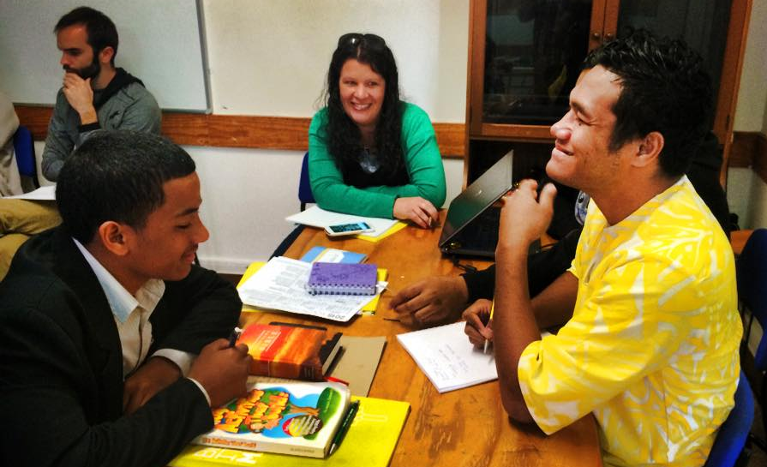
Raukura offers development and an opportunity to network and build relationships for Tikanga, Diocesan, Hui Amorangi and regional level youth leaders. In 2014, Raukura was led by Dr Sue Bagshawe, focussing on developing the skills of experienced youth workers to help young people who are hurting; understanding youth development and behaviour; dealing with the vulnerability of young people and increasing their protection; and, understanding Self Harm and Suicide, the difference between them, and how to keep young people mentally and emotionally healthy.

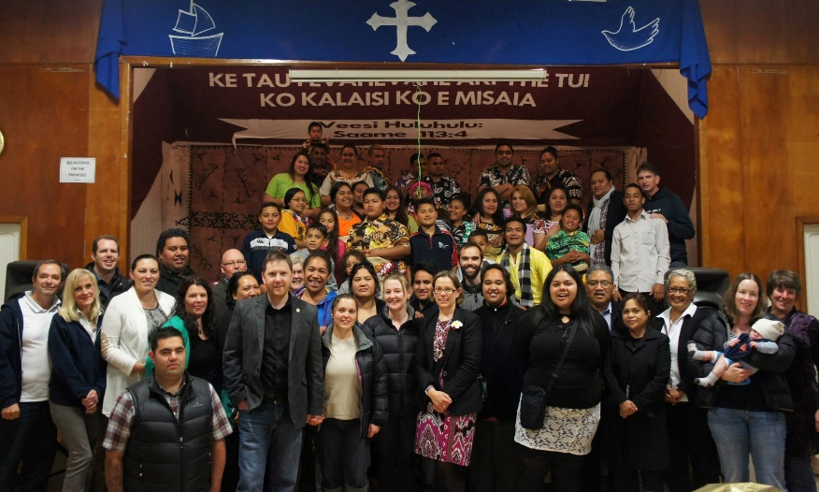
Expert facilitators, experienced in the area of health and working with at-risk youth, and with a personal understanding of a Church environment and framework, also helped us to ground these understandings in ways that are relevant to each of our contexts (Pākehā, Māori and Polynesia) to aid in the application of learning to our ministry in our own communities.

In 2015, the national StraNdZ Enabler, Diana Langdon, lead participants at Raukura through a new way of looking at stages and transitions in human and faith development with young people.
The Rev. Brian Dawson also helped participants to take another look at Confirmation and its place in the faith journey and development of young people as well as to address potential changes to the rite of confirmation in the ACANZP.
Theological Hui 16-18 July, 2015
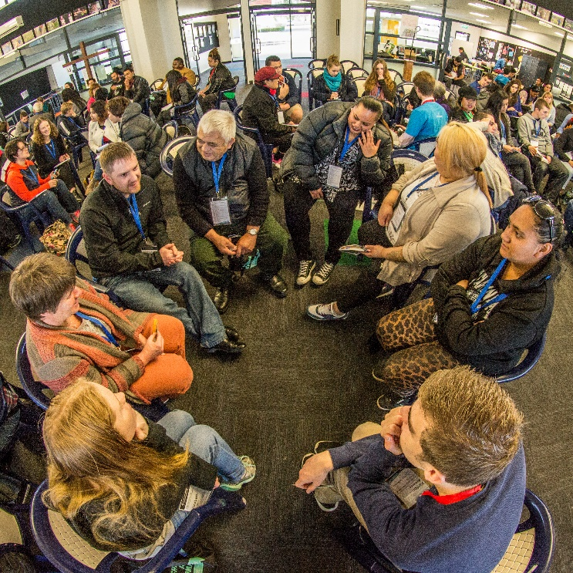
General Synod Standing Committee approached the T3YC in early 2013 to organise a Theological Hui. After some consideration the T3YC accepted. However, the proposal to hold it in 2014 was subsequently pushed to 2015 because it was felt that the bicentennial year was already too busy.
The T3YC settled on "Prepare the Way", where John points the way to Jesus in Luke, as the theme for the Theological Hui in 2015 This theme built on the bicentennial celebrations in 2014 and the key text, also from Luke (2:10), "I am bringing you good news of great joy for all the people." The challenge at the hui was to look ahead, to do theology around preparing the way and reminding ourselves what it means to be people of 'the way'.
Our experience of past Theological Hui was that all had been held at St John’s Theological College in Auckland and were geared mostly towards academic theology. In planning the hui for 2015, the T3YC wanted to make the hui more broadly accessible, with an emphasis on young people, and wanted to find a venue and location with a whakapapa that could be woven into our hui and kōrero.
Discussing the need to locate the hui in an environment and immersive experience that facilitates making meaning well and draws on the depth and treasure of our history the T3YC chose St Peter’s School in Cambridge. This enabled us to connect with the site of Waharoa and the life, example and legacy of the young martyr, Tarore. The significance here again of the Gospel of Luke fit well with the hui.
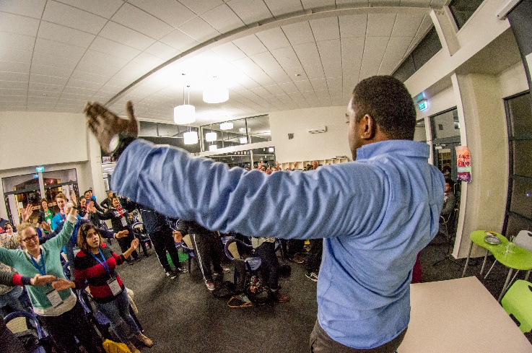
There were three Keynote presentations which broke the main theme into three sub-themes: Prepare the Way; Show the Way; and, Lead the Way. We kept a balance in Tikanga, gender and age in our presenters, partnering younger theologians with older more experienced counterparts for each Keynote.
The first, Prepare the Way, was delivered by Rev Donald Tamihere, Tumuaki of Te Rau College, Te Tairawhiti, and Rosa Filoi, Lecturer at the National University of Samoa and Youth Chaplain, Archdeaconry of Samoa. Don and Rosa spoke on trust—assessing the difference between High Trust and Low Trust relationships. In looking at preparing the way they posed the question to the hui whether we love and trust in the way that Jesus taught, or are we, without realising it, becoming the biggest obstacles to our own calling and success.
Low trust environments were typified as places defined by anxiety, suspicion, duplicity, and punitive behaviour while high-trust environments were defined by encouragement, support, creativity, innovation, and inspiration. Attendees at the hui were asked to look at and understand their own relationships in this light, to begin to prepare the way by focussing on trust and trusting in God.
The second, Show the Way, was delivered by Rev Ellen Bernstein, Vicar of St Stephen’s, Tamahere and Rev Ngira Simmonds, Maori Missioner, Waikato. Ngira and Ellen examined Luke 24:13-34 and the encounter with the risen Christ on the Road to Emmaus.
Looking more deeply at this encounter with Jesus they reflected on its meaning for the life of the Church and how we might avoid the temptation to stay solely in the upper room, at the last supper, and how we meet Christ in the stranger on the road, and the breaking of bread that happens in the Emmaus story.
If we think more deeply about the commandment, ‘do this to remember me’, they asked the question, what is ‘this’? The hui took this challenge to begin thinking about what this means for our life and community and for our Christian witness.
The third Keynote, Lead the Way, was delivered by the Very Rev Claude Fongtoy, Dean, Suva Cathedral, and Kirstin Cant, Youth Mobiliser, NZCMS. Claude and Kirstin examined Acts 2, Pentecost and the example of the early Church and the ideas that God uses ordinary people, like us, to do the extraordinary.
They shared that leading the way is not just about ideas in our mind, but it is about action—grounded first in the Gospel, how do we then proclaim that Good News and live it out in our everyday lives? They pointed to the example of the early Church and the way in which they were in fellowship together, in the breaking of bread, in prayer and hospitality—with faithfulness, awe and wonder.
Rather than slip into discussion again at the end of the hui, we arranged a number of activities to get participants to tie their thinking, and 'feeling', to their 'doing'. Activities included putting together a game-plan for action in their own communities around social justice; connecting with their creativity through art; expressing themselves through spoken word poetry; learning and marking the event with a waiata-ā-ringa composed especially for the hui; and gathering to pray, and compose prayer.
In the middle of our keynotes and time at the hui we also made a pilgrimage to Tarore’s resting place to remember the inspiring story of forgiveness and reconciliation, and spread of the Gospel, that flows from her life and death. Ngāti Haua, having welcomed us to the hui, also welcomed us on to the wāhi tapu that holds the memorial to Tarore. To commemorate the visit and karakia at the site each participant was gifted a Gospel of Luke.
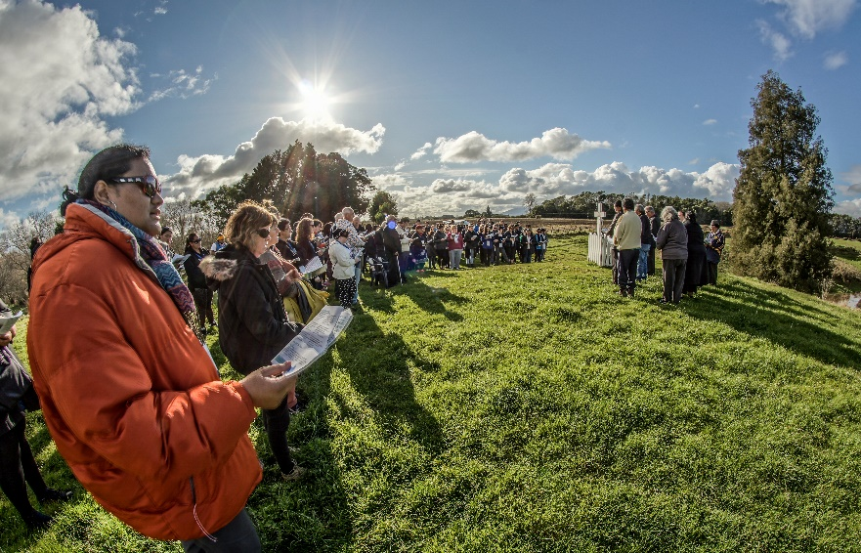
The pilgrimage to Waharoa, while hard to achieve in a short programme, was a highlight of the hui and makes a case for connecting hui to similar places of import—as was done, of course, with GS/THW and Oihi in 2014—where the environment and history can have an impact on how we make meaning.
It was also a privilege to have our Archbishops, Most Rev Brown Turei and Most Rev Philip Richardson journey each step with us, from the pōwhiri, the pilgrimage to Waharoa, being part of a panel answering questions participants had written down throughout the hui, through to the closing Eucharist.
Our practice of involving and providing a good balance of gender, Tikanga and ages in the presentations and running of the Hui, sourced from our own networks was appreciated and added great value to participants’ learning and enjoyment—weaving sessions together that speak from and to our voices, our places, our history, and our contexts is something worth continuing and developing—as well as allowing people to engage with and listen to presenters who they get to watch practice what they preach and relate to in multiple other settings in our Church.
This in turn was part of trying to engage participants on multiple levels—a head, heart, hands approach—understanding we all privilege different ways of learning and doing theology. The activities on the last day—reflecting on and expressing our theology through art, poetry, music, prayer—built on this while trying to get our brains firing on tying our thinking to our doing. We believe there is great value in exploring the use of more and varied activities as part of our learning and expression at hui.
Running a social screen at the hui was something new with attendees able to participate on Twitter, Instagram and Facebook using a hashtag and we were able to get discussion moving to these platforms, engage others not present at the hui, and take questions that way for one of the presentations. We also promoted stories, photo albums, and video Interviews through our social media platforms as well as on our website.
One challenge was that many assumed, despite it being stated otherwise, that as the T3YC was running the hui that it was aimed at young people; however, we still managed to get a mix of ages at the hui. In turn, the collaboration of young and old, cross-Tikanga, from different spectrums in our Church in terms of theology, faith and practice, the balance in gender, and how that was gathered at the hui felt natural and unforced in the end creating a positive welcoming and safe space in which to be 3T and do theology.
CLMC, Auckland, 6-9 October 2015
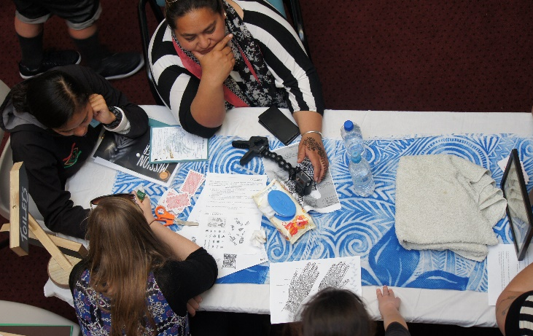
In partnership with the NZCMS Youth Mobiliser, Kirstin Cant, T3YC ran a youth stream at the Common Life Mission Conference (CLMC) in 2015. Responding to an invitation from Robert Kereopa, we offered a space within the optional afternoon workshops every day. Partly this was a space away from the rest of the hui for young people to hang out where we could offer some hospitality, but within that we offered a number of activities with a focus on mission including guided audio prayer stations on the 5 Marks of Mission as well as being available to talk through any questions they had around the content of the hui.
Tikanga Youth Synod, 26-28 February 2016
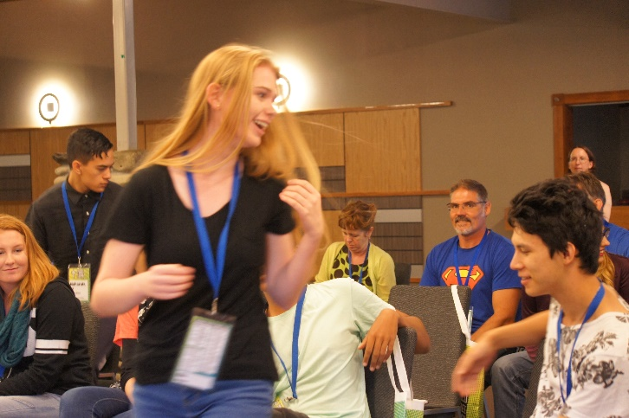
Tikanga Youth Synod, an annual gathering of young people and youth leaders from all three Tikanga was held at the Silverstream Retreat Centre in Lower Hutt, 26-28 February.
The theme of TYS in 2016 was Climate Change and Refugees and took place barely a week after Tropical Cyclone Winston made landfall in Fiji and began the day the first group of Syrian refugees arrived in Wellington since NZ had agreed to increase its intake.
The gathering heard a number of presentations and reflections. In the opening Keynote Address, Rt Rev Richard Ellena, Bishop of Nelson, stressed the importance of placing Jesus at the centre of all that was discussed at TYS, and walking together.
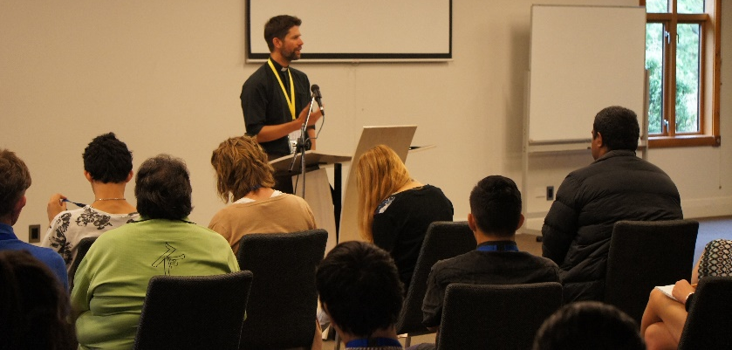
Rev Jolyon White, Director of Anglican Advocacy, Christchurch, spoke to the gathering on being clear about the goals of our advocacy, of careful and ongoing assessment of the rightness of our causes, and the deliberate and practical steps that need to be taken to deal with issues of injustice in achievable ways.
Fe‘iloakitau Kaho Tevi, Sustainable and Strategic Development Advisor from the Diocese of Polynesia, spoke on the causes and observable effects of Climate Change, of the impact of Climate Change on human lives in the Pacific, and the ethics of living within our means. The Youth Synod was challenged by Mr Tevi to carefully consider how our lifestyles and our connection to, and actions around, Climate Change affect the environment and our sisters and brothers in Tikanga Polynesia and the Pacific.
Sarah Morris, International Advocacy Manager, Unicef NZ, spoke on the Global Goals for Sustainable Development, thinking globally and acting locally, and her work volunteering with Red Cross NZ in hosting a refugee family. The Youth Synod heard how Climate Change and issues of injustice have a disproportionate impact on children, especially the most vulnerable.
In mixed-Tikanga groups the Youth Synod looked at how we can address the issues of Climate Change and Refugees in our own contexts and what that might mean in practical terms as well as how we might walk together and strengthen cross-Tikanga relationships and unity.
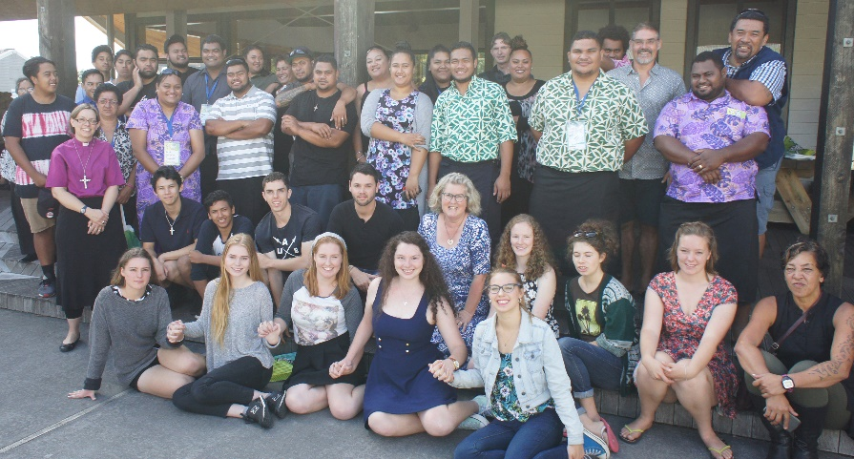
Each Tikanga also spoke in their own forums about the theme of our gathering as well as other issues important to them. Tikanga Polynesia, reporting back to the Youth Synod, made several proposals for consideration and further action by the T3YC including moving from acting out of sympathy and pity for our brothers and sisters in the Pacific towards efforts and resources to acknowledge and build for resilience and disaster preparedness as well as developing resources for prayer and education around these issues for the whole Church.
The engagement of young people, our present and future leaders, with the theme of the Youth Synod and their acceptance of their place at the centre of concerns for sustainable development to combat Climate Change, to fight injustice and inequality, and to welcome those displaced by unliveable situations also underlined the vital contribution young people have to make, and the importance of ensuring their voice is heard and that they have genuine participation in any decision making.
Participants have committed themselves to taking steps to work further on actions identified in small group work at our gathering and in Tikanga forums. The next meeting of Tikanga Youth Synod will take place in February 2017.
Sustainable Practices for Youth Ministry
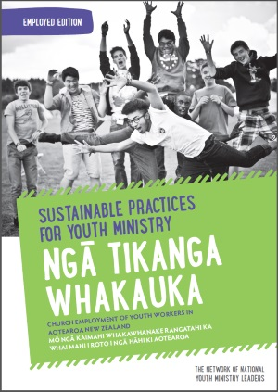
As part of the Network of National Youth Ministry Leaders, the T3YC has helped to design 'Sustainable Practices for Youth Ministry' - a straightforward resource that will lead you through making seven key commitments to Youth Workers or Lead Volunteer Youth Leaders to ensure a sustainable and successful youth ministry.
The Sustainable Practices resource started as an idea for church employed youth workers in 2007, and a national charter was officially developed in 2009 by youth ministry leaders in the UK. Under this charter, churches would be accredited if they committed to an accountable action plan. Churches across multiple denominations and parachurch organisations throughout the UK have now been accredited. A Canadian version was created in 2011, and in the USA, a covenant, based on the British national charter, was also launched in 2011.
For Aotearoa-NZ, the Network of National Youth Ministry Leaders—which includes national youth leaders from the Presbyterian, Methodist, Baptist, Assemblies of God, Salvation Army, Weslyan-Methodist and Anglican Churches—committed to contextualising this charter for our own communities. The accreditation process was removed, making it a free resource which any church can use. It was also deemed necessary to create a sister document for churches whose key youth leader is a volunteer. You can read more about the purpose of this resource, how to use it, and download a copy over at www.sustainablepractices.org.nz or check out our other resources at www.makethefirstmove.org.
Conclusion
We praise God for all those who engage in youth ministry across the Anglican Church in Aotearoa, New Zealand & Polynesia. From Tikanga events like The Abbey now having met for the third time in 2015 where it gathered over 200 youth leaders and young people from across Tikanga Pākehā as well as manuhiri from Tikanga Māori and Polynesia; the Kāhui Rangatahi National Hui that will take place before GS/THW in Rotorua and the energy and impetus a raft of new Hui Amorangi Youth Enablers are providing for youth ministry in Te Pīhopatanga o Aotearoa; the Anglican Schools Leadership Camp gathering students from across our Anglican Schools in Stratford, Taranaki in April; or the leadership of young leaders & youth ministry initiatives being placed at the heart of mission in the Diocese of Polynesia; through to Hui Amorangi & Diocesan events & programmes, youth & young adult groups & outreach, Sunday schools & one-on-one mentoring & discipling happening around the Three-Tikanga Church. There’s a lot to be thankful for and we are committed to seeing it grow further—discipling young people to be Christ-centred in our Three-Tikanga Church, developing young leaders and facilitating 3T relationships at the flaxroots.
Nā reira, e ōku rangatira, kia tau ngā manaakitanga o te Runga Rawa ki a tātau katoa, māna tātau e whakakaha, e tieki, e arahi kia tūtuki pai ai ā tātau mahi katoa ki tāna e pai ai. Noho ora mai i raro i te maru o Ihowā.

Membership 2014-2016

Ex-officio
Youth Liaison Bishop: Rt Rev. Dr Helen-Ann Hartley, Bishop of Waikato
General Secretary: Rev. Michael Hughes
General Synod Standing Committee Representative: Rev. Jo Crosse
National Youth Advisor, Tikanga Pākehā: Mr Phil Trotter
Ringa Arataki, Tikanga Māori: Merekaraka Te Whitu 2015
Youth Coordinator, Tikanga Polynesia: Archdeacon Sepiuta Hala‘api‘api

Nominated by the Tikanga Youth Synod, 2014

Tikanga Pākehā
Mrs Jaz Burke 2014-2015
Mr Chris Casey 2015-
Mrs Samantha Mould

Tikanga Polynesia
Ms Anastarzia Havili
Mr Guliano Bryce

Tikanga Māori
Ven. Lloyd Popata 2014-2015
Rev. Tony Brooking 2015-
Ms Rawinia Gray 2014-2015

